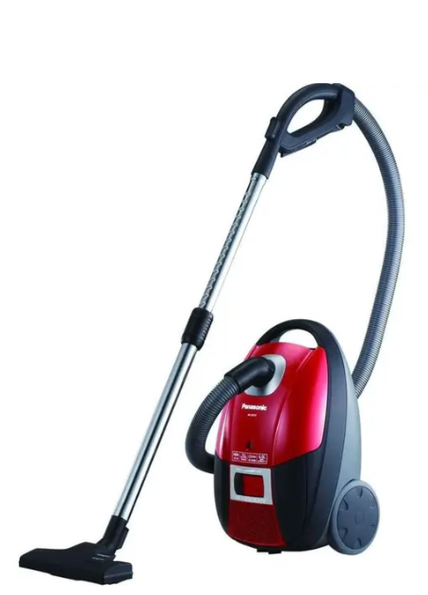

Panasonic Vacuum Cleaner
Rs.35,000
A Panasonic vacuum cleaner is a powerful cleaning appliance designed for removing dust, dirt, and allergens from floors, carpets, and furniture. It comes in different types such as canister, stick, handheld, and bagless models, suitable for home and office use.

Specifications
- Power: ~600W
- Dust Capacity: 0.3L – 4.2L
- Weight: 4.5kg – 12kg
- Noise Level: 70 dB(A)

Key Features
- High Suction Power
- Advanced Filtration System
- Long-Lasting Battery Life
- Versatile Attachments

